DSS 665 R Statistical Language Final Project
Life Expectancy Prediction

I. Project Understanding
Goal: Find factors statistically influencing lifespan, predict life expectancy and get insights among the results. Figure out the ways to improve general life expectancy, understand what and where we can make efforts to.
Issues:
1. What does the correlation matrix tell us?
2. Regardless of significance, what can we tell from the original linear regression?
3. Does various predicting factors which has been chosen initially really affect the Life expectancy? What are the predicting variables affecting life expectancy? How do those variables affect life expectancy?
4. What should a country do to improve its average lifespan?

II. Data Description
1. General Description
In this dataset we are going to predict the Life Expectancy based on various features which include Country, Year, Status, Adult Mortality, Infant Deaths, Alcohol, Percentage Expenditure, Hepatitis B, Measles, BMI, Under-Five Deaths, Polio, Total Expenditure, Diphtheria, HIV/AIDS, GDP, Population, Thinness 1-19 Years, Thinness 5-9 Years, Income Composition of Resources, and Schooling. All features are continuous variables apart from “Country” and “Status” which are categorical variables.
Here is a detailed description of all variables in the dataset:
Variable | Description | Data type
Country | Country name | Categorical
Year | Year | Date
Status | Developed or Developing Countries | Categorical
Life Expectancy | Life Expectancy in age | Numeric
Adult Mortality | Adult Mortality Rates of both sexes (probability of dying between 15 and 60 years per 1000 population) | Numeric
Infant Deaths | Number of Infant Deaths per 1000 population | Numeric
Alcohol | Alcohol, recorded per capita (15+) consumption (in litres of pure alcohol) | Numeric
Percentage Expenditure | Expenditure on health as a percentage of Gross Domestic Product per capita (%) | Numeric
Hepatitis B | Hepatitis B (HepB) immunization coverage among 1-year-olds (%) | Numeric
Measles | Number of reported cases per 1000 population | Numeric
BMI | Average Body Mass Index of entire population | Numeric
Under-Five Deaths | Number of under-five deaths per 1000 Numeric population | Numeric
Polio | Polio (Pol3) immunization coverage among 1-year-olds (%) | Numeric
Total Expenditure | General government expenditure on health as a percentage of total government expenditure (%) | Numeric
Diphtheria | Diphtheria tetanus toxoid and pertussis (DTP3) immunization coverage among 1-year-olds (%) | Numeric
HIV/AIDS | Deaths per 1 000 live births HIV/AIDS (0-4 years) | Numeric
GDP | Gross Domestic Product per capita (in USD) | Numeric
Population | Population of the country | Numeric
Thinness 10-19 Years | Prevalence of thinness among children and adolescents for Age 10 to 19 (%) | Numeric
Thinness 5-9 Years | Prevalence of thinness among children for Age 5 to 9(%) | Numeric
Income Composition of Resources | Human Development Index in terms of income composition of resources (index ranging from 0 to 1) | Numeric
Schooling | Number of years of Schooling(years) | Numeric

2. EDA
a. Categorical Variable
From the box plots, where show the relationship between life expectancy and two categories: developed countries and developing countries, we get an insight into their relation.
Life expectancy in developed countries is higher. The obvious difference indicates that the categorical variable “Status” might be a good predictor in the model. (Appendix 1)
b. Continuous Variables
The correlation matrix between features and target can give us a sense of which features can be a good predictor.
The correlation matrix between features and themselves shows a possibility of multicollinearity which we may need to avoid in the model.
We notice there are very strong correlations (>=0.9) between:
Infant deaths and under five deaths;
GDP and percentage expenditure;
Thinness 1-19 years and thinness 5-9 years.
(Appendix 2)
To show collinearity among independent variables, we’re supposed to check the Variance Inflation Factor (VIF), where we set 5 as the suspicious score. If the VIF is higher than 5, we would think that the variable has potential to cause multicollinearity.
Not surprisingly, the 3 highly correlated pairs in the correlation matrix also show high VIFs. So, we will omit one of each pair based on the value of VIF. For example, we will omit infant deaths as it has a higher VIF than under five deaths. For the same reason we omit GDP AND thinness 1-19 years. (Appendix 3)
After elimination, we check the correlation matrix and VIF again. We find the correlation matrix shows no highly suspicious coefficients that might indicate multicollinearity between the features. And the VIFs now are all within an acceptable range below 5. (Appendix 4)
Now we get this version of data that is for Model_EDA.

III. Data Preparation
1. Clean and filter data: remove unnecessary variables
Year and Country are removed as they are not related to the main question of the project, which cares more about what the main predictors of the life expectancy are regardless of where and when.
2. Missing data
As we can see from the plot, about 44% of the total data is missing. (Appendix 5)
The bar plot shows the amount of missing value per feature. The most significant amount of missing value is recorded in Population, GDP, Hepatitis B, followed by Total expenditure, Alcohol, Income composition of resources and Schooling. (Appendix 6)
Since we have around 44% of missing data, it’s not good to directly delete all the missing values in that it would lead to underperforming model; instead, we can apply data imputation. Firstly, we check outliers in each variable that contains missing values using boxplots; Then, we will apply imputation with median to the variables with high outliers and apply imputation with mean to the variables with low outliers.
The box plots that show no outlier or few outliers are Alcohol, BMI, Income composition of resources. We will apply mean for those variables and apply median to the rest of the variables. (Appendix 7)
3. Factorize categorical variables
We have one categorical variable after eliminating “Country” and “Year”. To prepare for the modeling, we need to convert “Status” to the dummy variable where 1 means Developing countries and 0 means Developed countries.
4. Data transformation
4.1 Response Variable
The target variable Life Expectancy is a little left-skewed. (Appendix 8)
We perform a square root transformation on Life Expectancy to make it more normally distributed, which matches the assumptions of applying linear regression.
After transformation and scaling, the skewness improved a bit. (Appendix 9)
4.2 Predictors
We scale the continuous variables which standardize every feature over a normal distribution to prepare for the modeling.
Now we get this version of data that is for Model_Full.
5. Feature selection methods
Feature selection is the process by which a subset of relevant features or variables are selected from a larger dataset for constructing models.
5.1 Best Subset
We will choose the best group of features based on 3 major metrics: residual sum of squares (RSS, the lower, the better); adjusted R2 (the higher, the better); Bayesian information criterion (BIC, the lower, the better).
The different metrics suggest different number of variables as the best subsets. We will choose the result provided by BIC metric since it has the minimum number of variables. (Appendix 10)
RSS | Adj R2 | BIC
16 | 16 | 12
5.2 Forward Inclusion
The forward inclusion with BIC metric also suggests 12 variables as the best subset. (Appendix 11)
5.3 Backward Elimination
The backward elimination with BIC metric also suggests 12 variables as the best subset. And the three methods choose the same variables with the same coefficients. (Appendix 12)
Here we get the third version of data that is for Model_FS.

IV. Modeling
1. Full Model (Appendix 13)
From the summary report, we know that we have in total 19 variables. Not all variables are significant.
The adjusted R2 is around 0.7894, which means this model can explain around 78.94% of the variance in the dataset.
The overall model is statistically significant since the p-value for F-test is very low.
2. EDA Model (Appendix 14)
We have in total 16 variables. Not all variables are significant.
The adjusted R2 is around 0.7845, which means that about 78.45% of the variance can be explained in this model.
The overall model is statistically significant since the p-value for F-test is very low.
3. Feature Selection model (Appendix 15)
We have in total 12 variables. All the variables are significant with a low p-value.
The adjusted R2 is around 0.784, which means that around 78.4% of the variance can be explained by this model.
The overall model is statistically significant since the p-value for F-test is very low.

V. Evaluation
Checking RMSE, Adjusted R2 and Linearity assumptions for each model, we find that:
The linearity assumptions are roughly met for all three models:
a. The Residuals vs Fitted plot
The residuals are randomly distributed. There is no pattern in the residual plots. we can assume a linear relationship between the predictors and the outcome variables. (linearity assumption)
b. The Scale-Location plot
The residuals are spread equally across the ranges of predictors. (homoscedasticity assumption)
c. The Normal Q-Q plot
All the points spread along the reference line equally, it’s good enough to assume that the data has the normality of the residuals. (normality of the residuals assumption)
d. The Residuals vs Leverage
Any point in the 0.5 cook distance boundary is influential. However, there are no influential points here. (linearity assumption)
(Appendix 16)

VI. Conclusion & Discussion
List the candidate models:
Model | Number of Variables | RMSE | Adj R2 | Linearity Assumptions
Full Model | 19 | 0.4462 | 0.7894 | All met
EDA Model | 16 | 0.4540 | 0.7845 | All met
Feature Selection Model | 12 | 0.4551 | 0.7840 | All met

1. Conclusion:
We compare all the models’ variations in terms of Number of variables, RMSE, adjusted R2 and Linearity assumptions. We can see how adjusted R squared and RMSE are very close, so we don't have much loss when removing those variables.
We can conclude that the Feature Selection Model provides good results given that it decreases the number of features.
Then we can say that the main factors that affect life expectancy in the best model are:
Status; Adult Mortality; Percentage Expenditure; Hepatitis B; Measles; BMI; Thinness 5-9 years; Polio; Diphtheria; HIV.AIDS; Income Composition of Resources; Schooling.
2. Insights:
a. What does the correlation matrix tell us? (Appendix 17)
It shows that Life Expectancy has negative relationships with thinness 5-9 years, thinness 10-19 years, population, HIV/AIDS, under five deaths, measles, infant deaths, and adult mortality; has positive relationships with schooling, income composition of resources, GDP, Diphtheria, total expenditure, Polio, BMI, Hepatitis B, percentage expenditure, and Alcohol.
Unsurprisingly, higher life expectancy tends to coincide with lower population, lower mortality rates, lower number of disease cases like HIV and Measles, longer school years, higher GDP and expenditure on health, and higher immunization coverage. One unexpected result is that higher alcohol consumption also contributes to higher life expectancy. But since the alcohol consumption is positively correlated with GDP, it makes sense. Although higher alcohol consumption is often associated with negative health effects, it's intriguing that in some instances, it seems to coincide with longer life expectancy. This positive correlation between alcohol consumption and life expectancy could be partially explained by the fact that alcohol consumption tends to be higher in countries with higher GDPs.
The correlation matrix shows that the target has a high positive correlation with the features 'Schooling', 'Income composition of resources', and 'BMI', and a high negative correlation with the features 'Adult mortality' and 'HIV/AIDS'. However, the correlations don’t establish causation. They provide a basis for further investigation and understanding of how these factors might interplay in influencing life expectancy across different regions or populations.
b. Regardless of significance, what can we tell from the original linear regression?
c. Does various predicting factors which has been chosen initially really affect the Life expectancy? What are the predicting variables affecting life expectancy? How does those variables affect life expectancy? (Appendix 18)
From the original linear regression summary report, we can still see that life expectancy is negatively correlated with some variables and positively correlated with some other variables. Since not all variables are statistically significant with low p-values, we cannot conclude that all the various predicting factors which have been chosen initially really affect life expectancy. What’s more, we know that in the best model we have some statistically significant variables that influence the response variable including Status; Adult Mortality; Percentage Expenditure; Hepatitis B; Measles; BMI; Thinness 5-9 years; Polio; Diphtheria; HIV/AIDS; Income Composition of Resources; Schooling. The insights we can gain from the report, for example, is that densely populated countries tend to have lower life expectancy. And the impact of immunization coverage on life expectancy is that the higher the coverage, the higher the lifespan. To be specific, the slope coefficient of Status Developing means that compared to developed countries, the average lifespan for developing countries decreases by 0.9341 year; and the slope coefficient of Schooling means that for each extra unit in Schooling, the life expectancy will on average increase by 0.8417 year.
d. What should a country do to improve its average lifespan?
Healthcare and Disease Prevention: Focus on reducing the prevalence of diseases like HIV/AIDS, measles, polio, diphtheria, hepatitis B, and alcohol-related illnesses. Investing in vaccination programs, disease awareness campaigns, and healthcare infrastructure can significantly impact life expectancy.
Nutrition and Health Education: Address issues related to thinness in different age groups (5-9 years and 10-19 years) by implementing nutritional programs targeting children and adolescents. Additionally, prioritize health education initiatives to improve overall BMI and nutrition standards across the population.
Child and Maternal Health: Reduce under-five deaths and infant mortality rates by enhancing maternal healthcare, access to prenatal and postnatal care, promoting safe childbirth practices, and improving overall child health services.
Education and Socioeconomic Factors: Invest in education systems and programs to improve schooling levels as higher education correlates with increased life expectancy. Also, focus on improving income distribution, GDP growth, and income composition of resources to ensure better access to healthcare, nutrition, and overall quality of life for all citizens.
Public Health Infrastructure: Increase total healthcare expenditure and percentage expenditure dedicated to public health. This could include investing in healthcare facilities, medical research, and accessible healthcare services for all sections of society.
Alcohol and Health Awareness: Address alcohol-related issues through awareness campaigns, regulations, and support systems for addiction treatment and rehabilitation programs.
3. Future Improvements
The current project contributes to giving advice to governments and people who make efforts to improve lifespan. For the future work, I may consider three different paths: the first is to keep year and country columns to discuss time series or utilize panel data to see the influence of when and where on life expectancy.
In the model, we can also add new variables which tend to effect life expectancy-such as religions, eating habits, exercise habits and so on.
The last one is to separate the models for developing and developed countries to see if there is a better model performance.
We can also try some further evaluations related to the realistic life-it is a good idea to keep track of the future data in the following years as our new test set to see if the model still performs well and to find somewhere to improve regarding the future development.

Appendix
1. Boxplot of Life Expectancy by Country Status
2. Correlation Matrix
3. VIF score
4. New correlation matrix and VIF score
5. Missing vs Non-missing Row Counts
6. Bar Plot of Missing Counts
7. Box Plot of Each Feature
8. Original Distribution Density of Response
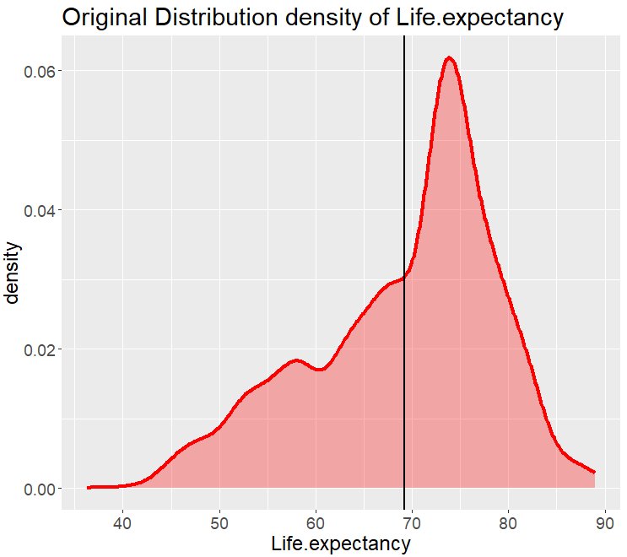
9. Transformed Distribution Density of Response
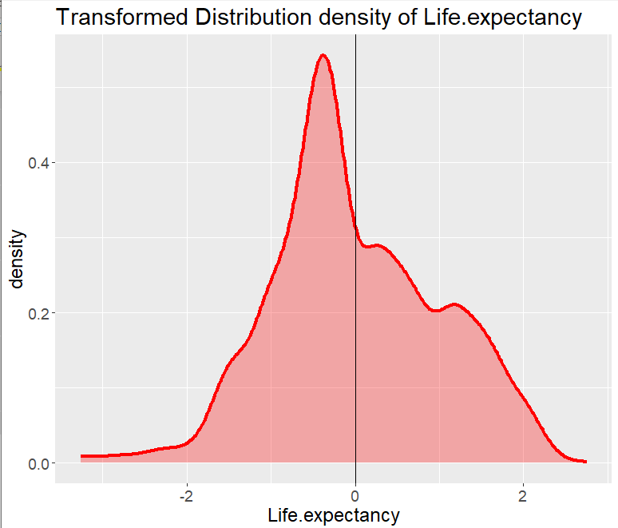
10. Number of Variables of Three Metrics & Feature Coefficients
11. Forward Inclusion
12. Backward Elimination
13. Full Model Summary Report
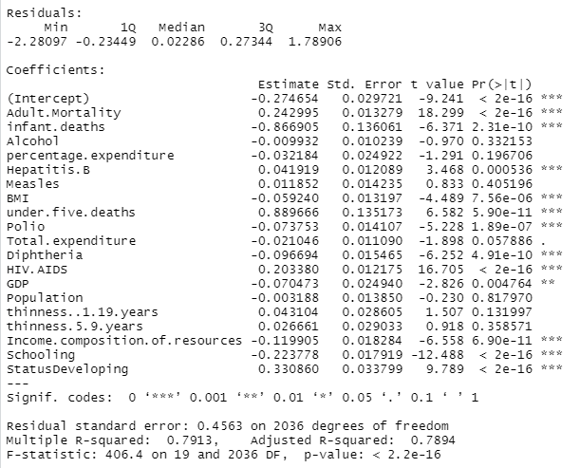
14. EDA Model Summary Report
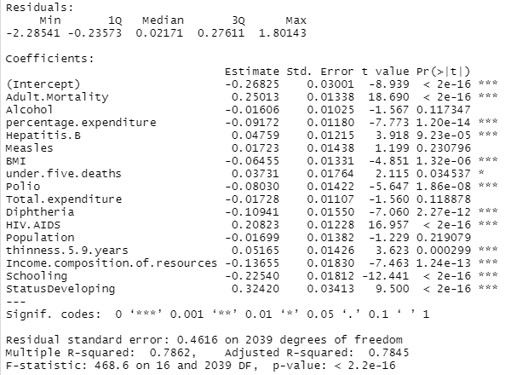
15. Feature Selection Model Summary Report
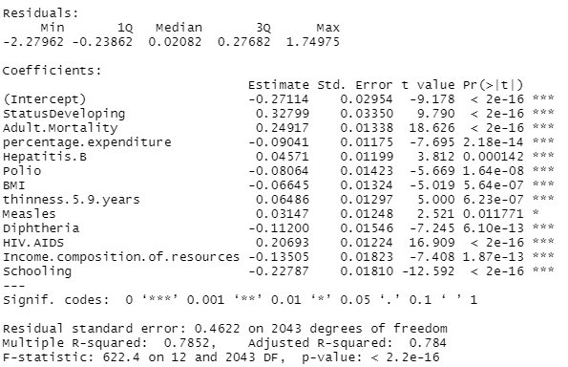
16. Evaluation
17. Original Correlation Matrix
18. Original Linear Regression Model Summary Report
